**Week 3 Course Project Ph3**

Kaustubh Prakash Deolase

University of the Cumberlands

ITS-538-A05: Database Systems

Dr. Michael Wayne Johns

Feb 25, 2024

**Question. Analyze The ERD For A Student Information System Provided Below. Be Alert for The Specifications Provided For: 1) Entities, 2) Attributes, 3) Primary Key, And 4) Relationships. You Will Need to Have A Clear Understanding For These Components To Create Your Database Using MySQL.**

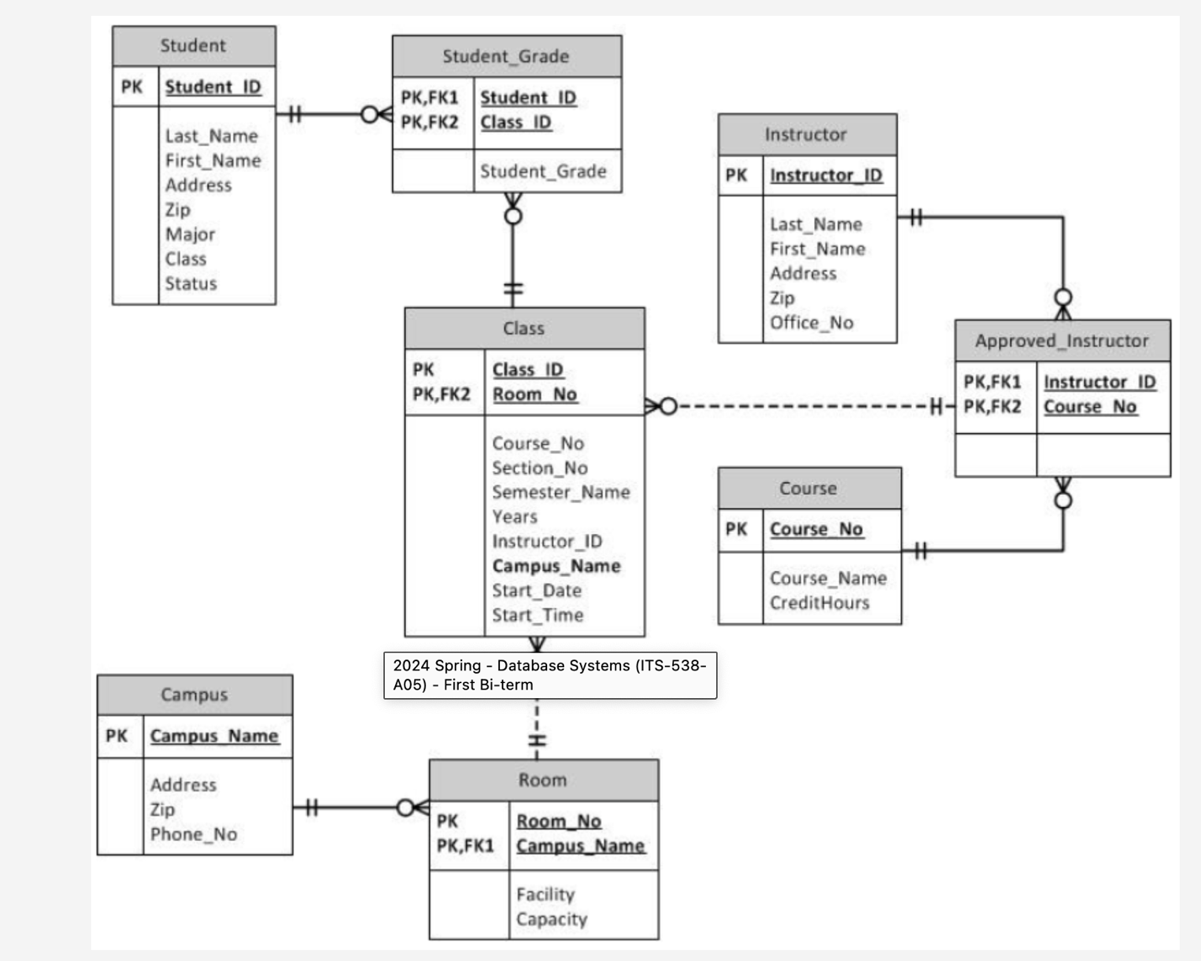

**#1. To Create the Data Table for Entity- Student:**

**Query:**

SET FOREIGN_KEY_CHECKS=0;

DROP TABLE IF EXISTS STUDENT;

SET FOREIGN_KEY_CHECKS=1;

CREATE TABLE STUDENT(

STUDENT_ID INTEGER AUTO_INCREMENT NOT NULL PRIMARY KEY,

Last_Name VARCHAR(30),

First_Name VARCHAR(30),

Address VARCHAR(40),

ZIP VARCHAR(10),

MAJOR VARCHAR(20),

CLASS int(2),

STATUS VARCHAR(20));

INSERT INTO STUDENT (Last_Name, First_Name, Address, ZIP, MAJOR, CLASS, STATUS)

VALUES('Sharma','Ravi','flat no. 3, Newlands High','410501','COMMERSE',2,'FAILING');

INSERT INTO STUDENT (Last_Name, First_Name, Address, ZIP, MAJOR, CLASS, STATUS)

VALUES('Yadav','Nitish','234, Yadavs Residence','410501','PHYSICS',3,'SATISFACTORY');

INSERT INTO STUDENT (Last_Name, First_Name, Address, ZIP, MAJOR, CLASS, STATUS)

VALUES('Jain','Nitish','121, Kanjabag','262308','COMPUTER SCIENCE',1,'FAILING');

Commit;

SHOW TABLES;

Select * from STUDENT;

**Result:**

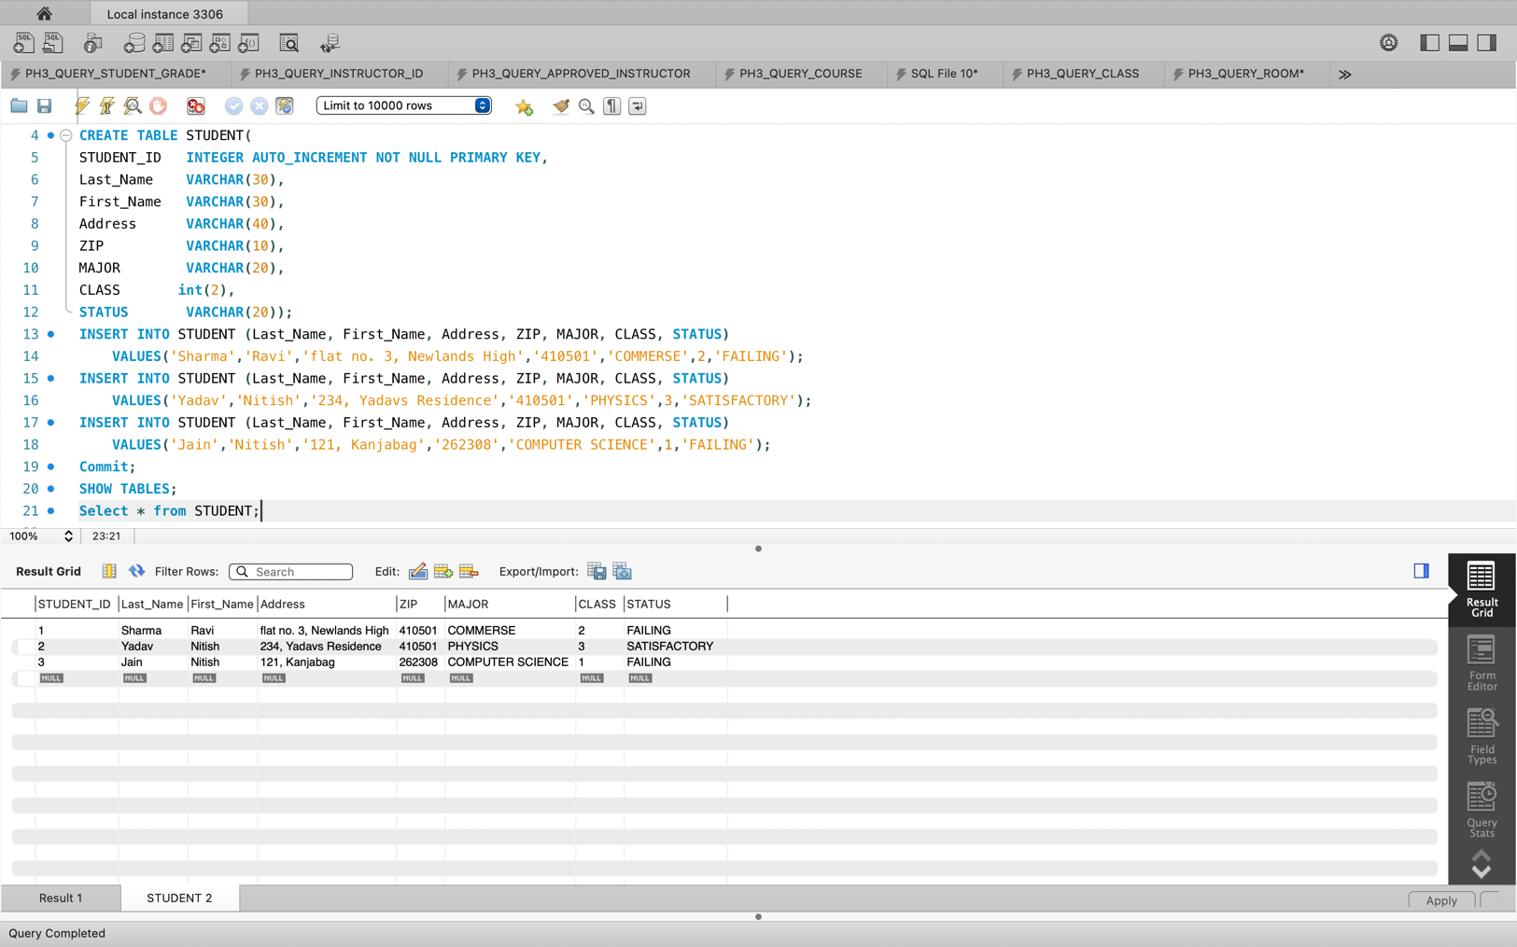

**#2. To Create the Data Table for Entity- Student_Grade:**

**Query:**

SET FOREIGN_KEY_CHECKS=0;

DROP TABLE IF EXISTS STUDENT_GRADE;

SET FOREIGN_KEY_CHECKS=1;

CREATE TABLE STUDENT_GRADE

(

Student_ID MEDIUMINT NOT NULL AUTO_INCREMENT,

Class_ID Varchar(10),

Student_Grade ENUM('A','B','C','D',"E",'F','I','W'),

PRIMARY KEY(Student_ID)

);

INSERT INTO STUDENT_GRADE (Student_ID,Class_ID, Student_Grade)

VALUES('1','1001','F');

INSERT INTO STUDENT_GRADE (Student_ID,Class_ID, Student_Grade)

VALUES('2','1002','B');

INSERT INTO STUDENT_GRADE (Student_ID,Class_ID, Student_Grade)

VALUES('3','1003','F');

Commit;

SHOW TABLES;

select * from student_grade;

**Result:**

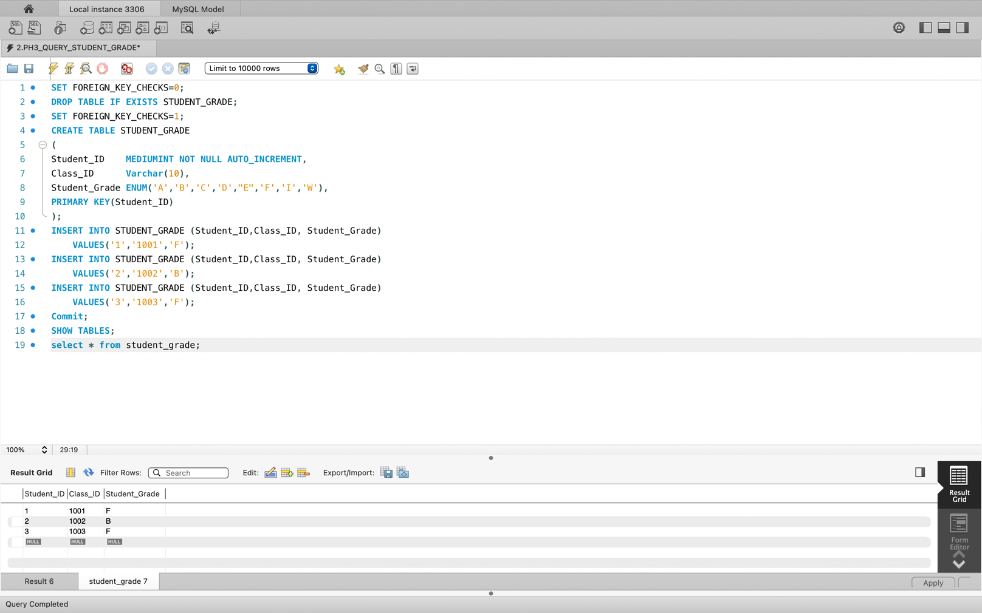

**#3. To Create the Data Table for Entity- Instructor:**

**Query:**

SET FOREIGN_KEY_CHECKS=0;

DROP TABLE IF EXISTS INSTRUCTOR;

SET FOREIGN_KEY_CHECKS=1;

CREATE TABLE INSTRUCTOR

(

INSTRUCTOR_ID VARCHAR(15) NOT NULL,

LAST_NAME VARCHAR(30),

FIRST_NAME VARCHAR(30),

ADDRESS VARCHAR(40),

ZIP VARCHAR(10),

OFFICE_NO VARCHAR(10),

UNIQUE(INSTRUCTOR_ID),

PRIMARY KEY(INSTRUCTOR_ID)

);

INSERT INTO INSTRUCTOR(Instructor_ID,LAST_NAME,FIRST_NAME,ADDRESS,ZIP,OFFICE_NO)

VALUES('A111','Khote','Appu','borivali west','333333','1');

INSERT INTO INSTRUCTOR(Instructor_ID,LAST_NAME,FIRST_NAME,ADDRESS,ZIP,OFFICE_NO)

VALUES('B222','Tara','Ishan','xyz 10th st','123456','2');

INSERT INTO INSTRUCTOR(Instructor_ID,LAST_NAME,FIRST_NAME,ADDRESS,ZIP,OFFICE_NO)

VALUES('C333','Kohli','Virat','Delhi 6, gali 3','555555','3');

INSERT INTO INSTRUCTOR(Instructor_ID,LAST_NAME,FIRST_NAME,ADDRESS,ZIP,OFFICE_NO)

VALUES('D444','Feku','Salim','malad 6th st.','999999','4');

Commit;

Show tables;

Select * from INSTRUCTOR;

**Result:**

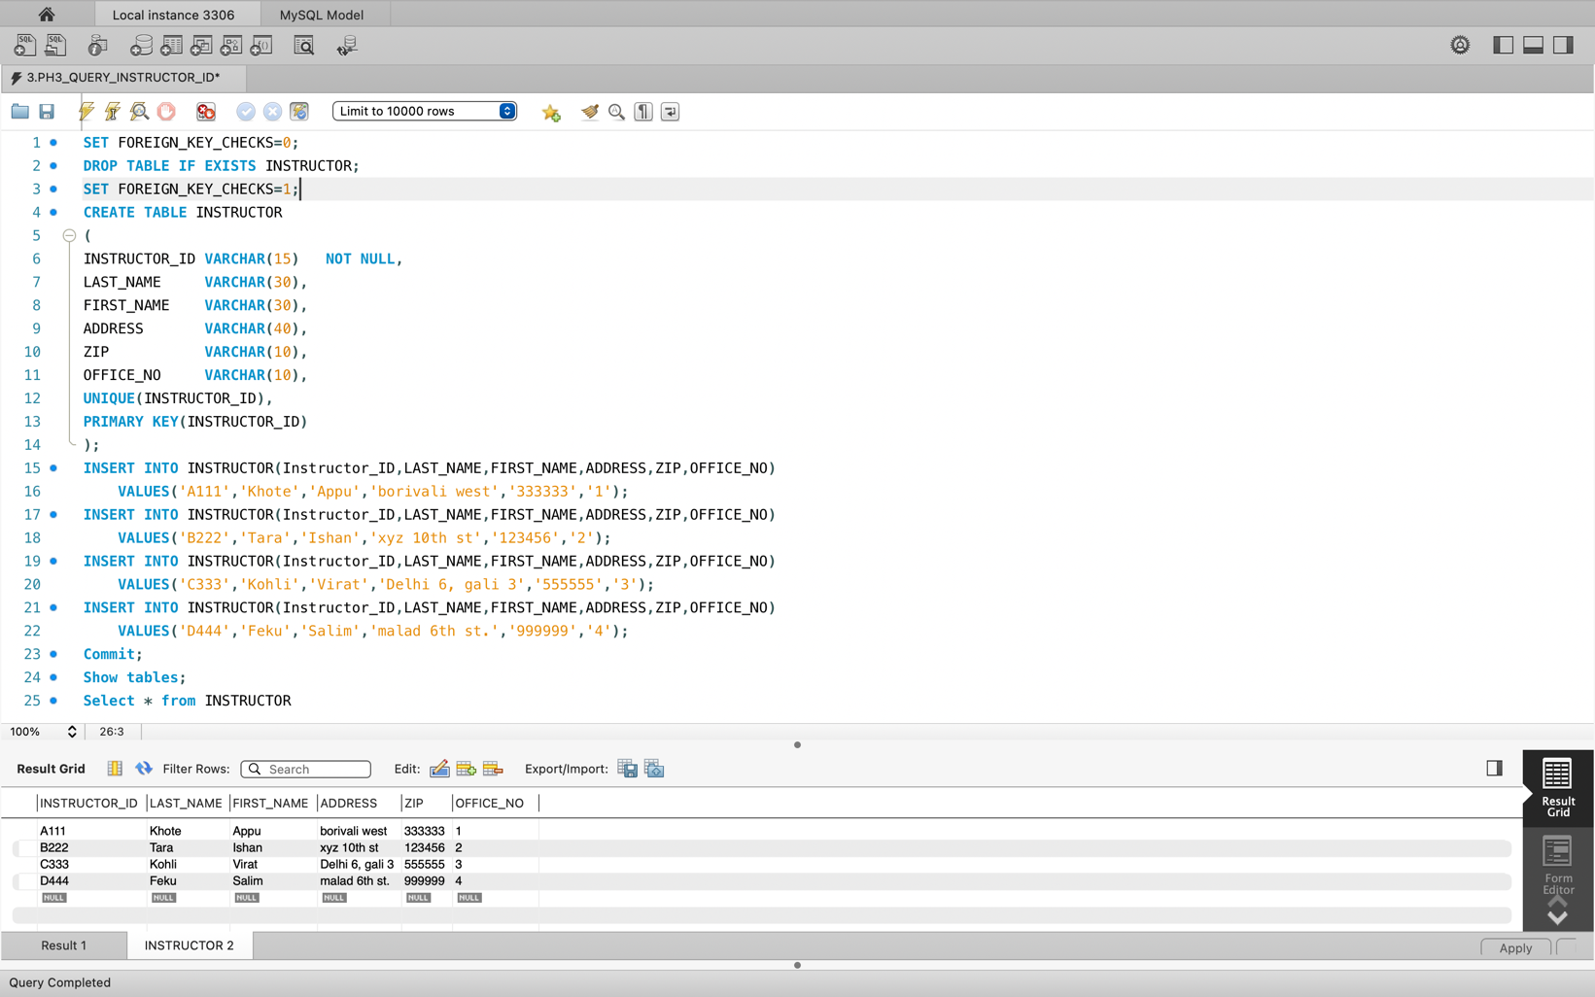

**#4. To Create the Data Table for Entity- Approved_Instructor:**

**Query:**

SET FOREIGN_KEY_CHECKS=0;

DROP TABLE IF EXISTS APPROVED_INSTRUCTOR;

SET FOREIGN_KEY_CHECKS=1;

CREATE TABLE APPROVED_INSTRUCTOR

(

Instructor_ID VARCHAR(10) NOT NULL,

Course_No VARCHAR(10) NOT NULL

);

INSERT INTO APPROVED_INSTRUCTOR(Instructor_ID, Course_No)

VALUES('A111','M1');

INSERT INTO APPROVED_INSTRUCTOR(Instructor_ID, Course_No)

VALUES('B222','M2');

INSERT INTO APPROVED_INSTRUCTOR(Instructor_ID, Course_No)

VALUES('C333','M3');

INSERT INTO APPROVED_INSTRUCTOR(Instructor_ID, Course_No)

VALUES('D444','M4');

Commit;

Show tables;

Select * from APPROVED_INSTRUCTOR;

**Result:**

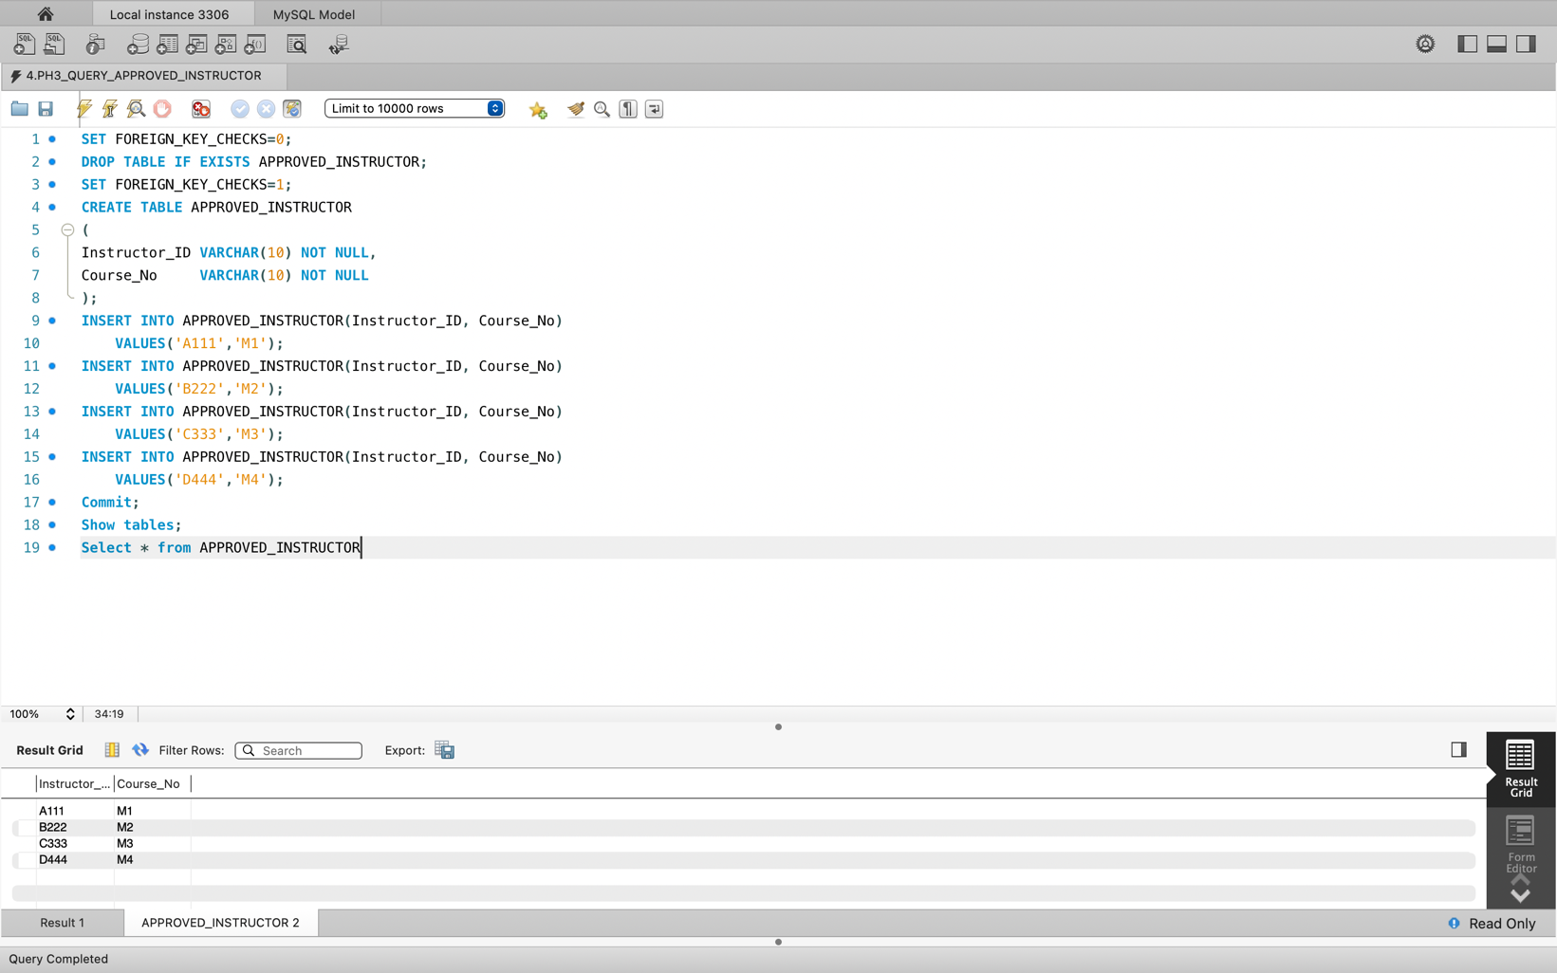

**#5. To Create the Data Table for Entity- Course:**

**Query:**

SET FOREIGN_KEY_CHECKS=0;

DROP TABLE IF EXISTS COURSE;

SET FOREIGN_KEY_CHECKS=1;

CREATE TABLE COURSE

(Course_No VARCHAR(10) not null,

Course_Name VARCHAR(20),

CreditHours VARCHAR(2),

UNIQUE KEY (Course_No),

PRIMARY KEY (Course_No));

INSERT INTO COURSE(Course_No,Course_Name,CreditHours)

VALUES('M1','MATHS',2);

INSERT INTO COURSE(Course_No,Course_Name,CreditHours)

VALUES('M2','PHYSICS',2);

INSERT INTO COURSE(Course_No,Course_Name,CreditHours)

VALUES('M3','CHEMISTRY',2);

INSERT INTO COURSE(Course_No,Course_Name,CreditHours)

VALUES('M4','COMPUTER SCIENCE',2);

COMMIT;

SHOW TABLES;

SELECT * FROM COURSE;

**Result:**

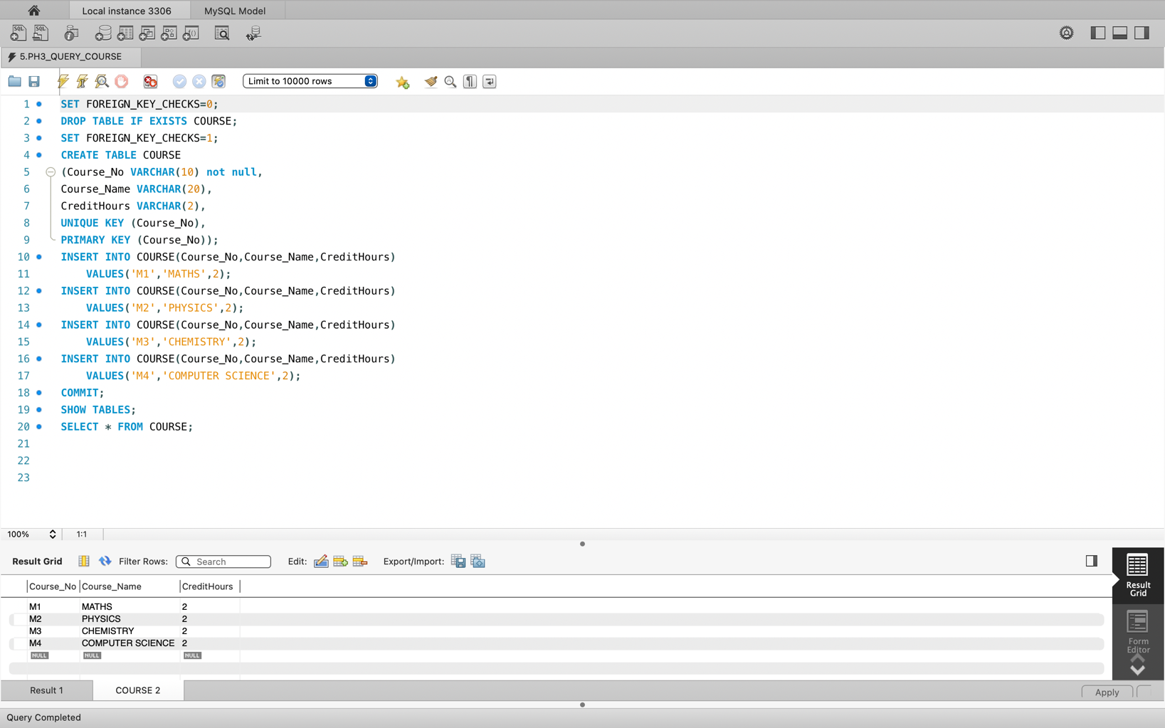

**#6. To Create the Data Table for Class:**

**Query:**

SET FOREIGN_KEY_CHECKS=0;

DROP TABLE IF EXISTS CLASS;

SET FOREIGN_KEY_CHECKS=1;

CREATE TABLE CLASS

(Class_Id Varchar(10) Not Null,

Room_No Varchar(10),

Course_No Varchar(10),

Section_No Varchar(10),

Semester_Name Varchar(15),

Year int(4),

Instructor_Id Varchar(20),

Campus_Name Varchar(20),

Start_Date Varchar(20),

Start_Time Varchar(20),

Unique Key(Class_Id),

Primary Key(Class_Id));

INSERT INTO CLASS(Class_ID,Room_No,Course_No,Section_No,Semester_Name,Year,Instructor_ID,Campus_Name,Start_Date,Start_Time)

VALUES('1001','RN0001','M1','SN100','FALL','2024','A111','SFO','2024-02-08','8:00');

INSERT INTO CLASS(Class_ID,Room_No,Course_No,Section_No,Semester_Name,Year,Instructor_ID,Campus_Name,Start_Date,Start_Time)

VALUES('1002','RN0002','M2','SN101','FALL','2024','B222','CHICO','2024-02-08','8:00');

INSERT INTO CLASS(Class_ID,Room_No,Course_No,Section_No,Semester_Name,Year,Instructor_ID,Campus_Name,Start_Date,Start_Time)

VALUES('1003','RN0003','M3','SN102','SPRING','2024','C333','FRESNO','2024-02-08','8:00');

INSERT INTO CLASS(Class_ID,Room_No,Course_No,Section_No,Semester_Name,Year,Instructor_ID,Campus_Name,Start_Date,Start_Time)

VALUES('1004','RN0004','M4','SN103','SUMMER','2024','D444','LA','2024-02-08','8:00');

commit;

show tables;

Select * from CLASS;

**Result:**

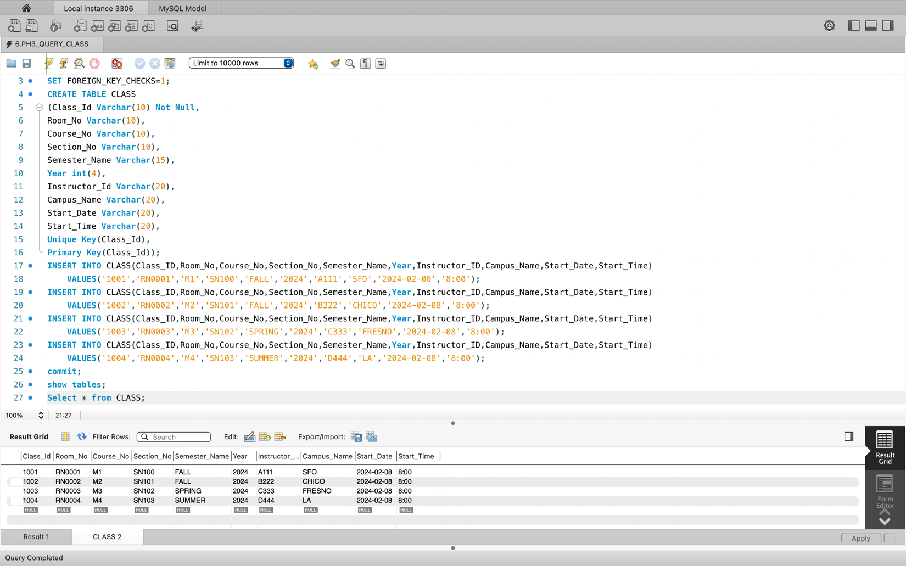

**#7. To Create the Data Table for Room:**

**Query:**

SET FOREIGN_KEY_CHECKS=0;

DROP TABLE IF EXISTS ROOM;

SET FOREIGN_KEY_CHECKS=1;

CREATE TABLE ROOM

(

Room_No Varchar(200) NOT NULL,

Campus_Name VARCHAR(20),

Facility Varchar(200),

Capacity Int(2),

PRIMARY KEY(Room_No)

);

INSERT INTO ROOM(Room_No,Campus_Name,Facility,Capacity)

VALUES('RN0001','SFO','Free Wi-fi,Job fair,Low Intrest Student Loan & Grants, Laptop, Library Accesses, Subsidised Meal,In-Campus Job','50');

INSERT INTO ROOM(Room_No,Campus_Name,Facility,Capacity)

VALUES('RN0002','CHICO','Free Wi-fi,Low Intrest Student Loan & Grants, Library Accesses, Subsidised Meal,In-Campus Job','50');

INSERT INTO ROOM(Room_No,Campus_Name,Facility,Capacity)

VALUES('RN0003','FRESNO','Free Wi-fi,Job fair,Low Intrest Student Loan & Grants, Laptop, Library Accesses, ,In-Campus Job','50');

INSERT INTO ROOM(Room_No,Campus_Name,Facility,Capacity)

VALUES('RN0004','LA','Free Wi-fi,Job fair,Low Intrest Student Loan & Grants, Laptop, Library Accesses, Subsidised Meal','50');

Commit;

SHOW TABLES;

Select * from ROOM;

**Result:**

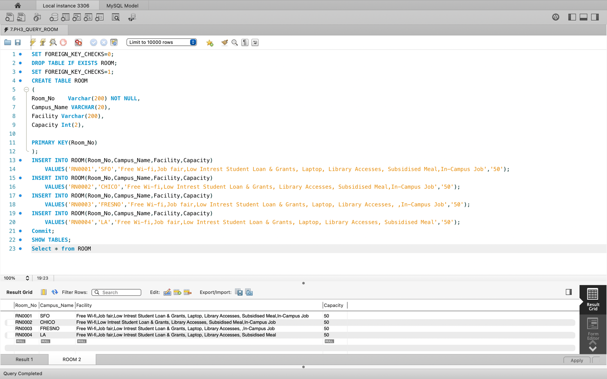

**#8. To Create the Data Table for Room:**

**Query:**

SET FOREIGN_KEY_CHECKS=0;

DROP TABLE IF EXISTS CAMPUS;

SET FOREIGN_KEY_CHECKS=1;

CREATE TABLE CAMPUS

(

#SerialNo MEDIUMINT NOT NULL AUTO_INCREMENT,

Campus_Name Varchar(10) Not Null,

Address Varchar(200) NOT NULL,

Zip VARCHAR(20),

Phone_Number Varchar(200),

PRIMARY KEY(Campus_Name)

);

INSERT INTO CAMPUS(Campus_Name,Address,Zip,Phone_Number)

VALUES('SFO','1600 Holloway Avenue San Francisco','94132','+1 415-338-2234');

INSERT INTO CAMPUS(Campus_Name,Address,Zip,Phone_Number)

VALUES('CHICO','400 West First Street Chico','95929-0722','+1 530-898-6322');

INSERT INTO CAMPUS(Campus_Name,Address,Zip,Phone_Number)

VALUES('FRESNO','5241 N. Maple Avenue Fresno','93740','+1 559-278-2261');

INSERT INTO CAMPUS(Campus_Name,Address,Zip,Phone_Number)

VALUES('LA','5151 State University Drive Los Angeles','90032','+1 323-343-3901');

Commit;

SHOW TABLES;

Select * from CAMPUS;

**Result:**

